# RS-449 – Sub-D 37 Pin

|  |  |  |  |  |  |  |  |  |  |
| --- | --- | --- | --- | --- | --- | --- | --- | --- | --- |
| **1** | VTN0355 (1) - Vermelho | **9** | VTN0355 (7) - Amarelo | **17** | Rele Inferior (7) – Roxo | **25** | Rede (4) – Vermelho | **33** | - |
| **2** | VTN0355 (2) - Preto | **10** | - | **18** | Rele Inferior - (1) – Laranja | **26** | Rede (3) – Preto | **34** | - |
| **3** | + 12V | **11** | Rele Inferior (1) – Marrom | **19** | Rele Inferior + (2) – Vermelho | **27** | Rede (2) – Marrom | **35** | - |
| **4** | - 12V | **12** | Rele Inferior (2) – Vermelho | **20** | Pictograma + (4) – Vermelho | **28** | Rede (1) – Laranja | **36** | - |
| **5** | VTN0355 (3) - Amarelo | **13** | Rele Inferior (3) – Laranja | **21** | Pictograma LH (3) – Verde | **29** | Rele Inferior + (6) – Vermelho  **Sup. Solenoide Giro** | **37** | - |
| **6** | VTN0355 (4) - Verde | **14** | Rele Inferior (4) – Amarelo | **22** | Porta 30 Laranja | **30** | Porta 22  Branco  **Sup. Solenoide Giro** |  |  |
| **7** | VTN0355 (5) – Vermelho | **15** | Rele Inferior (5) – Verde | **23** | Pictograma LAH (1) – Azul | **31** | Rele Inf. RL1 C (2) – Azul  **Sup. Relê Cofre** |  |  |
| **8** | VTN0355 (6) - Preto | **16** | Rele Inferior (6) – Azul | **24** | - | **32** | Rele Inf. RL1 NF (3) - Azul  **Sup. Relê Cofre** |  |  |

Conector Superior

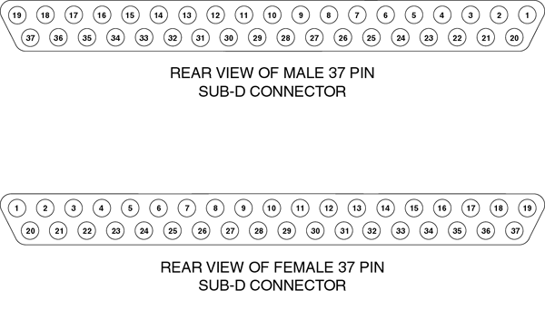

Conector Inferior